Aylmer Mystery Article (1)

Meet the Biracial Twins No One Believes are Sisters
By Chris Perez, March 2, 2015 | 12:30pm
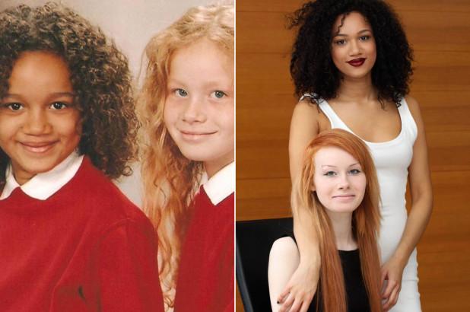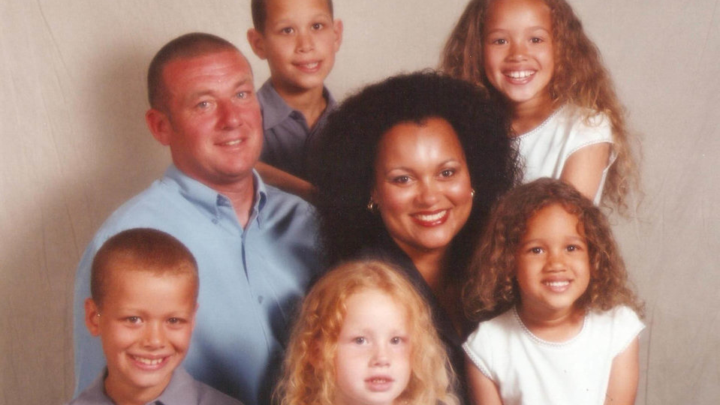
Meet Maria and Lucy, the bi-racial twins who have often been mistaken for friends instead of sisters because of their skin tones. There’s a set of biracial twins in the UK who are turning heads because one is black and the other is white.
Born in 1997 to a white father and a half-Jamaican mother, the sisters have grown accustomed to getting mistaken for being just friends — and they have even had to produce their birth certificates in order to prove they are in fact related, Barcroft Media report “No one ever believes we are twins because I am white and Maria is black,” Lucy explained. “Even when we dress alike, we still don’t even look like sisters, let alone twins.”
After giving birth naturally, the twins’ mother, Donna Douglas, did a double take as she looked at her daughters for the very first time. “It was such a shock for her because obviously things like skin color don’t show up on scans before birth,” Lucy said. “So she had no idea that we were so different. When the midwife handed us both to her, she was just speechless.”
And when it comes to the girls’ personalities, they are nearly as different as their looks. Lucy, who has red hair and a very fair complexion, studies art and design at Gloucester College, according to Barcroft. Maria, who has brown hair with a caramel complexion, studies law and psychology at Cheltenham College. They have three siblings, who all have mixed skin color.
“All our older brothers and sisters have a skin color which is in between Maria and I,” Lucy said. “We are at opposite ends of the spectrum and they are all somewhere in between. Lucy says one of the great things about having a twin who looks completely different is that people don’t mistake them for one another. “We were in the same class at infant school, but no one ever had a problem telling us apart,” she explained. “Most twins look like two peas in a pod — but Maria and I couldn’t look more different if we tried. We don’t even look like we have the same parents, let alone having been born at the same time.”
Summary of article:

Genetics is the study of how genes and traits are inherited over generations. In this unit you will examine the mechanisms organisms use to pass their genes to offspring, and you will study how the mechanisms of genetics can create diversity between individuals as closely related as the Aylmer twins.
Observations (5 observations for each):
- What traits do Maria and Lucy and share?
- What traits make Maria and Lucy different?
- How do Maria and Lucy compare to their parents?
Make a claim/hypothesis for how Maria and Lucy Aylmer can be twins but look so different. Explain your claim/hypothesis as best as possible using information you have. (1 paragraph)

Further Study: What are two questions you need to explore to better understand the variation between Maria and Lucy Aylmer?

