Chromosomes and Genetics Article (2)
“What is the cellular basis for physical traits?”
The Aylmer sisters demonstrate individuals as closely related as twins can have very different physical features despite the fact they have the same parents and they were born at the same time. To scientifically understand this observation, it is important to understand the basis for physical characteristics, or traits. In this class we will define a trait as a physical characteristic that can be inherited. For example, the red and black hair of Lucy and Maria Aylmer is an example of a trait. It is a physical characteristic that was inherited from their parents.
The information for a trait is encoded in the chemical structure of DNA. While this class will focus on human genetics, keep in mind every single organism on planet Earth uses DNA to encode traits. The chemicals that help bacteria infect you are found in DNA. The taste and color of an orange is encoded in DNA. The cute physical traits of your fish, reptile, dog, cat, or other pet are encoded in your pet’s DNA.
A specific portion of DNA that encodes a trait is called a gene. A gene is a specific segment of DNA that contains instructions to make a protein. The physical effect of this protein creates a trait. For example, the information to make the protein melanin is found at a specific gene. This melanin protein will then make hair a certain color.
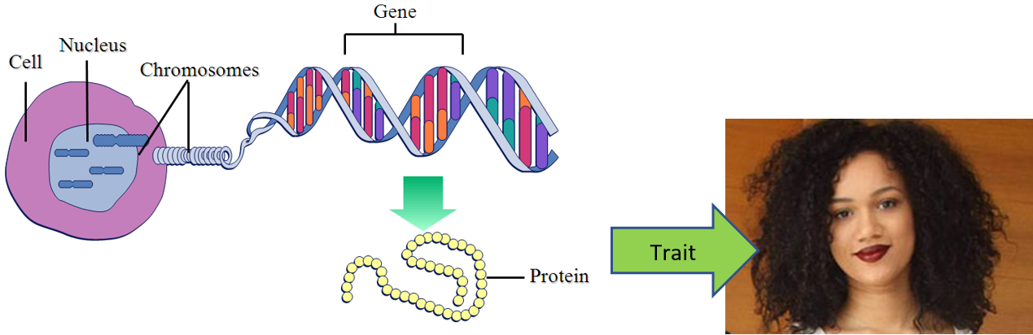
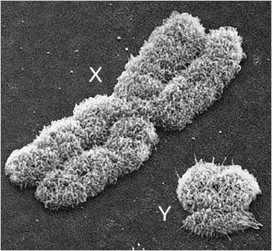
Figure 1: The above diagram shows the connection between DNA, genes, proteins, and traits.
Organisms have more than one gene. Currently it is estimated that humans have between 20,000 to 25,000 genes. These genes are located on structures called chromosomes. Chromosomes are long strands of DNA packaged with proteins. Each chromosome contains many genes. For example, researchers have discovered around 2,000 genes on a human’s chromosome 1. Also, organisms have more than 1 chromosome. Humans have 46 total chromosomes in each cell. Dogs have 78 chromosomes. Some species of ants have only two chromosomes, while the atlas blue butterfly contains a total of 452 chromosomes.
Figure 2: SEM image of sex chromosomes.
You have probably heard the saying, “half of your genes comes from your mom and half of your genes come from your dad.” This saying is true. Humans are diploid organisms. (“Di-“ is 2 and “-ploid” refers to chromosomes) We have 2 of the same chromosome. Each cell has a set of 23 chromosome pairs. Double this number and you land at 46.
Pairs of chromosomes are called homologous chromosomes. In a set of homologous chromosomes, one chromosome comes from you mother and one comes from your father. These two homologous chromosomes have the same length, general appearance, and genes; however, homologous chromosomes are not identical. They can contain a different genetic sequence.
Chromosomes are divided into two types: autosomes and sex chromosomes. Homologous chromosome pairs 1-22 are called autosomes. They contain genes that do not directly relate to the sex of an individual, and they follow the general rule that homologous pairs have the same length and appearance. They are numbered based on homologous pair size. 1 is the largest and 22 is the smallest.
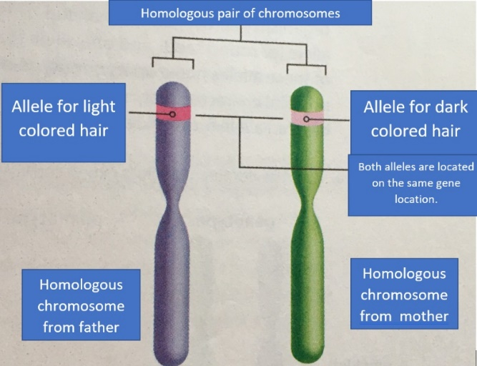
Homologous chromosome pair 23 is called a sex chromosome. Sex chromosomes contain genes that control the development of sexual characteristics in an organism. In humans these chromosomes are labelled as X and Y. In general individuals with XX chromosomes are female, and individuals with XY chromosomes are male. For humans the Y chromosomes is much smaller and contains fewer genes than the X chromosomes.
Even though Lucy and Maria Aylmer have very different hair colors, the proteins to make this hair color are found at the same gene on the same homologous chromosome. Whether a person has red, blonde, brown, or black hair, the same genes are at work. How can this be? All organisms have different versions of the same gene. These different versions are called alleles. The version of a gene for Lucy’s red hair is one version, or allele, and Maria’s black hair is another version, allele, of the same gene.
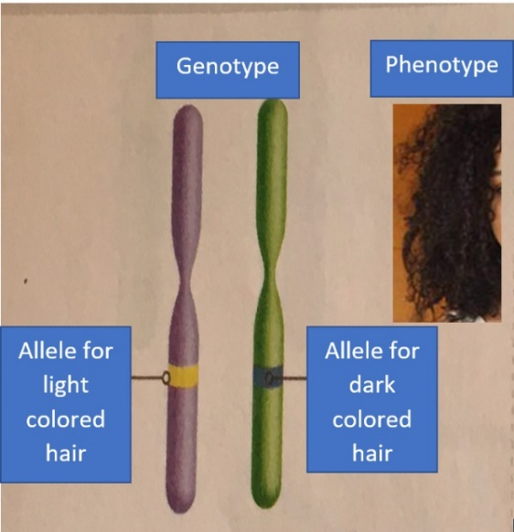
Figure 3: Homologous Chromosomes

Humans have two alleles for a gene. Remember your chromosomes are in homologous pairs. You receive one allele from each parent. If the alleles are identical to each other, the gene is considered homozygous. If the alleles are different, the gene is considered heterozygous. The description of the genetic makeup of pairs of alleles are called genotypes. The physical trait these two alleles make is called a phenotype. Both alleles help determine the phenotype of an organism. For example, Maria Aylmer’s genotype is heterozygous for the alleles of a hair color gene. Her phenotype is dark hair.
Figure 4: Genotype v. Phenotype

