Continental Drift and Evolution
The Theory of Continental Drift is defined as the movement of the Earth’s continents relative to each other, thereby appearing to drift together across the oceanic bed. German scientist, Alfred Wegener, was able to produce a viable hypothesis with evidence and specifically state the theory, but it should be noted there were previous geologists and scientists who thought similar to Wegener. For example, between 1889 and 1909 Roberto Mantovani speculated that all continents had once been conjoined in a “supercontinent,” and even developed an expanding Earth hypothesis. This supercontinent was called Pangea.
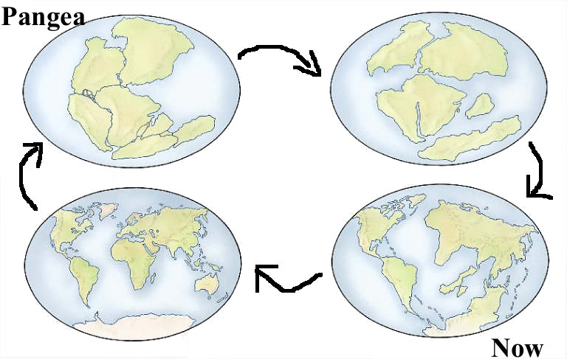
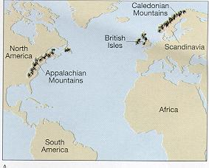
Alfred Wegener’s curiosity toward the possibility of continental drift came in 1910 after he noticed how Earth’s continents resembled pieces of a jigsaw puzzle. For example, he noted how South America coast correctly lined up with the coast of Northwest Africa. It wasn’t until 1911, when Wegener came across several scientific documents listing fossils of identical plants and animals found on opposite sides of the Atlantic that his passion for the subject truly showed. Reflecting on this monumental moment in his life, he wrote, “A conviction of the fundamental soundness of the idea took root in my mind.” Alfred Wegener knew massive amounts of evidence needed to be collected in order to justify such a fantastic idea—because with no practical driving force behind it the theory loses most of its credit. In order to maximize evidence for his theory and overlook the absence of a mechanism, he decided to draw from a variety of scientific fields including geology, geography, biology, and paleontology.

Geologic Evidence
Alfred Wegener collected diverse pieces of evidence to support his theory, including geological “fit” and fossil evidence. It is important to know that the following specific fossil evidence was not brought up by Wegener to support his theory. Wegener himself did not collect the fossils, but he called attention to the importance of using scientific evidence.
Geological “fit” evidence is the matching of large-scale geological features on different continents. It has been noted that the coastlines of South America and West Africa seem to match up, however more particularly the terrains of separate continents conform as well. Examples include: the Appalachian Mountains of eastern North America linked with the Scottish Highlands, the familiar rock strata of the Karroo system of South Africa matched correctly with the Santa Catarina system in Brazil, and the Brazil and Ghana mountain ranges agreeing over the Atlantic Ocean.
Fossil Evidence
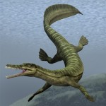
Another important piece of evidence in the Continental Drift theory is the fossil relevance. There are various examples of fossils found on separate continents and in no other regions. This indicates that these continents had to be once joined together because the extensive oceans between these land masses act as a type of barrier for fossil transfer. Four fossil examples include: the Mesosaurus, Cynognathus, Lystrosaurus, and Glossopteris.
The Mesosaurus is known to have been a type of reptile, similar to the modern crocodile, which propelled itself through water with its long hind legs and limber tail. It lived during the early Permian period (286 to 258 million years ago) and its remains are found solely in South Africa and Eastern South America. Now if the continents were in still their present positions, there is no possibility that the Mesosaurus would have the capability to swim across such a large body of ocean as the Atlantic because it was a coastal animal.
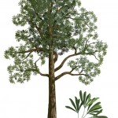
Possibly the most important fossil evidence found is the plant, Glossopteris. Known as a woody, seed bearing tree, the Glossopteris is named after the Greek description for tongue due to its tongue shaped leaves and is the largest genus of the extinct descendant of seed ferns. Reaching as tall as 30 meters, the Glossopteris emerged during the early Permian period (299 million years ago) and became the dominant land plant species until the end of the Permian. The Glossopteris fossil is found in Australia, Antarctica, India, South Africa, and South America—all the southern continents. Now, the Glossopteris seed is known to be large and bulky and therefore could not have drifted or flown across the oceans to a separate continent. Therefore, the continents must have been joined at least one point in time in order to maintain the Glossopteris’ wide range across the southern continents.
If the continents of the Southern Hemisphere are put together, the distribution of these four fossil types form continuous patterns across continental boundaries. Of course, possible explanations are brought to attention. One explanation is the species could have migrated via a land bridge or swam to the other continents. However, a land bridge is not applicable due to the differences in densities between the continents and oceans floor and violation of the isostasy concept. Moreover, swimming as a possibility is foolish due to the lack of formidable swimming capabilities to travel across such an extensive body of water like the Atlantic. An additional resolution is that the species could have merely evolved separately on the other continents. Undoubtedly, this interpretation is in complete disagreement with Darwin’s evolution theory.

Instructions:
You will be piecing together a puzzle of the supercontinent Pangea based on fossil and rock evidence on the present day continents.
- On the puzzle pieces handout, assign a color to each type of fossil or mountain belt in the legend and color the areas on the landmasses according to the legend.
- Use scissors to cut along the borders of the continents. These are the approximate shape of the continents after Pangea broke up.
- Place the continents on a piece of construction paper and move them around using the fossil and mountain chain evidence to match the continents together in the position they were in when they were part of Pangea. The pieces may not fit together exactly!
- When you have assembled Pangea based on the fossil and rock locations, glue the continents onto your construction paper in the shape of the supercontinent. Glue the legend to your puzzle.

Questions (Answer on the back of the paper)
- What is the idea of Continental Drift?

- What is Pangea? What modern day continents make up Pangea?

- Which 2 continents have the most obvious fit of the coastlines?

- How were the fossil symbols and mountain belts helpful in deciding where to move the continents?

- Why don’t the present shapes of the continents fit perfectly into a supercontinent?

- Which fossil occurs on the most landmasses? What does this suggest about when these continents broke up?
- What evidence does continental drift provide to the idea Earth and the organisms on it have changed over time?
- Write two other questions you could ask to further investigate the theory of continental drift?
- Based off this activity, how can you use this explain the presence of marine fossils in the central valley?

USGS
Fossil and Mountain Chain Evidence

DIRECTIONS: 1) Label each continent with its name.
2) Color the fossils or mountains in the legend and color the symbols on each
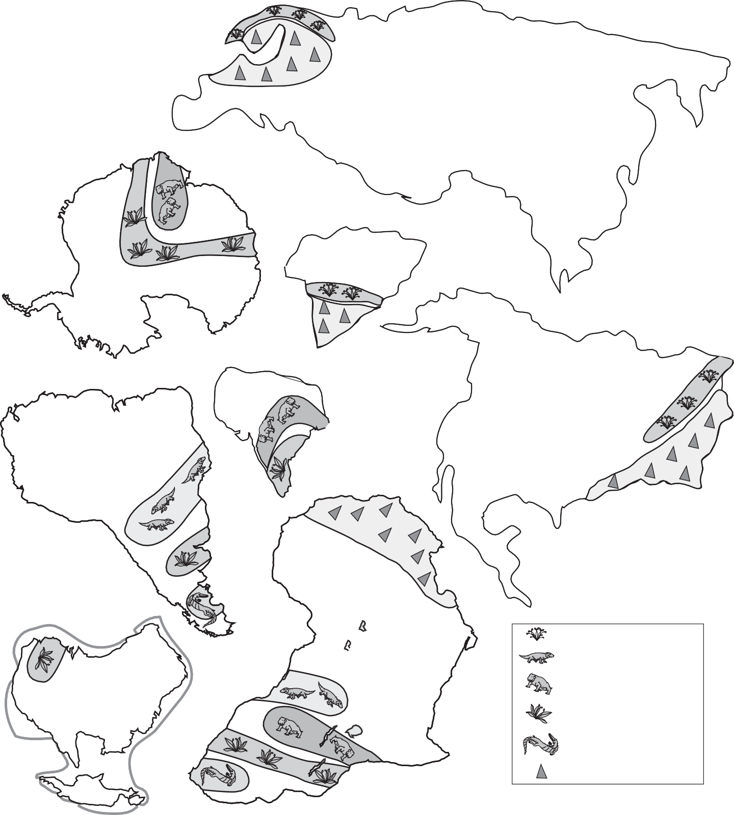
continent in the colors of the legend. 3) Cut out the continents and match up the fossil and mountain evidence to
recreate Pangea. 4) Glue the continents into place on your construction
paper.

Greenland

India

The European Flora Cynognathus reptile Lystrosaurus reptile Glossopteris plant
Mesosaurus reptile Alpine Mountains

Modified From:
U.S. Department of the Interior
U.S. Geological Survey
This Dynamic Planet; A Teaching Companion Wegener’s Puzzling Continental Drift Evidence
U.S. Geological Survey, 2008
For updates see <http://volcanoes.usgs.gov/about/edu/dynamicplanet>

D-65

