Corn Genetics CER
Does the inheritance of color and sweetness of corn follow Mendelian Inheritance rules?

While yellow-colored sweet corn on the cob is the most familiar type of corn to most Americans, there are thousands of different varieties of corn around the world. Most of the variation within corn deals with the color of the kernels and/or the amount of sugar present inside the kernel. While yellow is the most familiar color of corn, corn kernels can also be white, red, or purple-colored. Another trait of corn deals with the ratio of sugar to starch that is stored inside each kernel. Sweet corn has a lot of sugar inside the kernels, while field corn that is fed to livestock, has mostly starch inside the kernel and is not sweet when eaten. Besides eating corn another way to determine if a corn kernel has mostly sugar or starch inside is to let the corn cob dry and to observe the shape of each kernel. Sugar solution inside corn kernels will evaporate as a corn cob dries, this results in sweet corn having kernels that are wrinkled when dried. In contrast, starch does not dissolve in water very well, and field corn with high concentrations of starch will have kernels that maintain their round smooth shape even when dried.
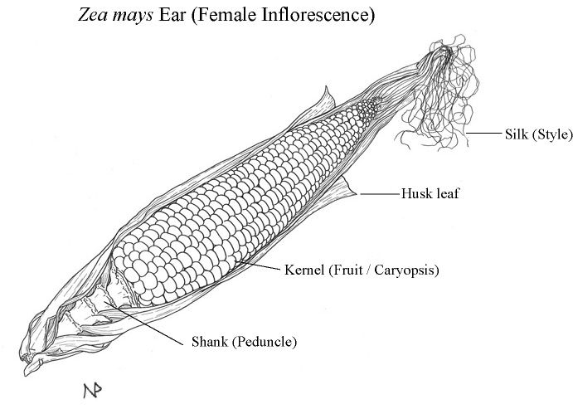
Mendel bred thousands of pea plants over many years to collect all of his data. Studying corn provides a short cut advantage over studying individual plants due to how corn plants reproduce. The silk that is located on the end of a corn cob is actually hundreds of female flowers. Each silk strand is independently pollinated and leads back to a single corn kernel. Counting the kernels on a single corn cobb would be the equivalent of breeding, growing, and collecting data from over 500 individual plants.

Goal: Your goal is to collect data from an experiment to determine if the color of corn kernels and the sweetness of corn follow the basic rules discovered by Mendel in his experiments. You will have to use your evidence collected to support your claim and then reason, or justify, why these traits follow or do not follow Mendel’s rules.

Question: Do color and sugar content of corn follow Mendel’s rules of inheritance?

Experimental Set Up

Parental Generation

Purple and Starchy (Round) Yellow and Sweet (Wrinkled)

X

↓

F1 Generation
Purple and Starchy
Draw a Punnett Square for the following:
Parental Generation Cross

F1 Generation Self-Pollination

What would be the genotypes for corn in the F1 generation?

Genotype for Purple:

Genotype for Starchy:

F1 Generation Plants Allowed to Self-Pollinate:

F2 Generation Data Collection:

Color:

# of Purple Kernels _______

# of Yellow Kernels ________

Ratio Purple: Yellow __________

Starch/Shape:

# of Starchy Kernels (Round) _______

# of Sweet Kernels (Wrinkled) _______

Ratio Starchy: Sweet ___________

Individual Kernel Data:

# of Purple Starchy Kernels _________

# of Purple Sweet Kernels __________

# of Yellow Starchy Kernels ________

# of Yellow Sweet Kernels _________

Key:
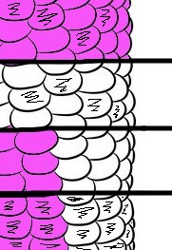
= Purple Kernels

= Yellow Kernels

= Starchy/Round Kernels

= Sweet/Wrinkled Kernels

Research Question:  What is the scientific question you are investigating? |  | Do color and sugar content of corn follow Mendel’s rules of inheritance?
Our Claim:
What claim can you make based on the scientific evidence and reasoning?
Evidence:  What are the science observations or data that address your questions? |  |  | Scientific Reasoning:  Explain how your evidence justifies your claim.
Scientific Explanation and Concepts:
Using the information in the boxes you have completed, write a scientific explanation that includes all of the information.

