Coronavirus Case Study (10)
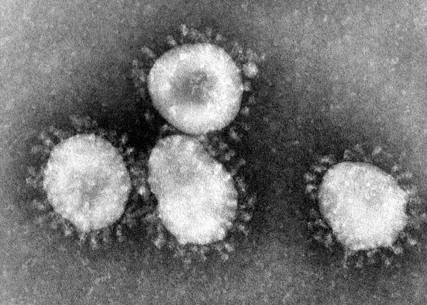
Part 1- Symptoms
Novel Coronavirus (COVID-19) has become a global threat. As of March 3, 9 people have died in the USA, and the number of people who are becoming infected has grown. For months the only people who contracted the disease in America had directly traveled to Wuhan, China, or lived in close proximity to a traveler to China. Now infections are being reported by people who have no links to people travelling to China.
The Leonard family has been following the coronavirus outbreak closely. They know symptoms of a COVID-19 infection include:
- Fever
- Dry Cough
- Fatigue (feeling extremely tired)
- Shortness of Breath
On Tuesday, Lucy Leonard woke up to her family coughing and looking like they did not sleep at all that night.
Leonard Family Member | Symptoms
Lucy Leonard (daughter) | No symptoms
Lucas Leonard (son) | Cough, headache
Linda Leonard (mom) | Cough, fever
Liam Leonard (dad) | Cough, fever, fatigue

Linda was concerned that everybody woke up sick. The night before, all four grandparents had come over to eat dinner. Now the whole Leonard family was worried. Could they have COVID-19?
- With what you know about COVID-19, write three questions you would ask the family to learn more about their risk for actually having COVID-19?

- What would you recommend that they do?

Part 2- Hospital Visit.
Worried that they in fact have novel coronavirus (COVID-19), the Leonard family travels to Clovis Community Hospital to get a check up. The doctor assesses their symptoms, and she decides she needs to perform a test to see if they do in fact have coronavirus in their system.
The doctor takes a throat swab of the Leonard family, and stores them in tubes to be sent to the lab. Lucy, 15, is in biology and wants to know how the doctor will test and see if they have coronavirus. The doctor explains that the cells will be lysed (broken up) and they will extract the DNA. Once the DNA is extracted, the lab will add restriction enzymes to the DNA sample.
Here is an animation showing restriction enzymes:
https://dnalc.cshl.edu/resources/animations/restriction.html
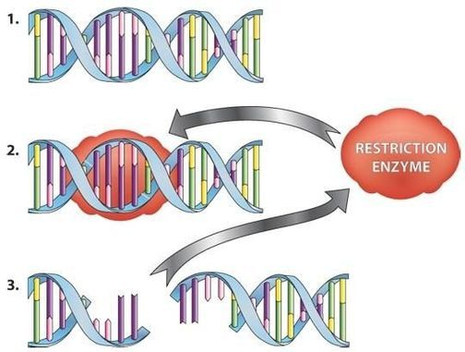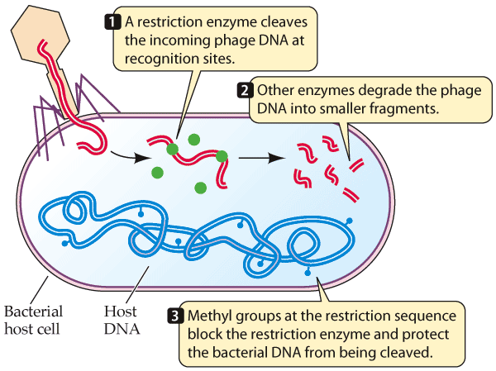
Figure 1 and 2: Restriction Enzymes Cutting Viral DNA
- What are restriction enzymes?

- What would restriction enzymes do to viral DNA?

- How could a restriction enzyme be used to detect the presence of coronavirus?

Part 3- Lab Testing
Now the doctor explains the lab will use EcoRI restriction enzyme to cut up DNA from the throat swab samples. Labs have discovered COVID-19 gives a unique DNA fingerprint in the presence of the restriction enzyme EcoRI.
To find this DNA fingerprint, the lab will run the DNA samples through gel electrophoresis.
Click through the animation on gel electrophoresis https://dnalc.cshl.edu/resources/animations/gelelectrophoresis.html
- Based on the animation explain how gel electrophoresis works.

Here are the results of gel electrophoresis of the throat swab.
COVID-19 Finger print
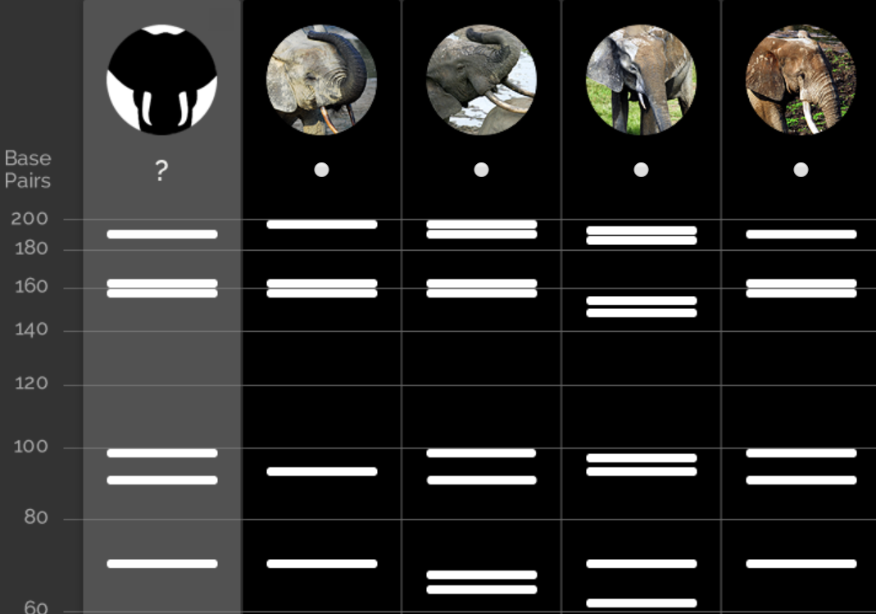
Linda
Liam
Lucas
Lucy

- Based on the gel electrophoresis above, who has coronavirus? Why is that?

Part 4- Making a Vaccine
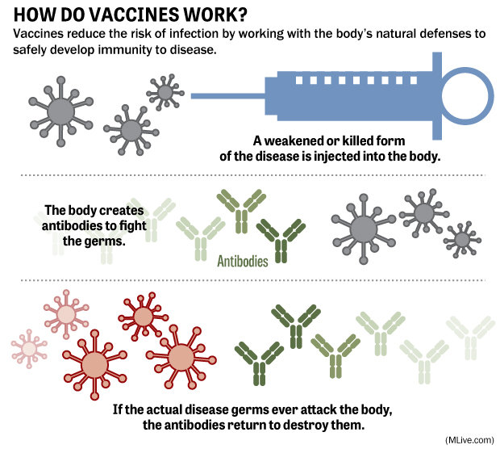
As the number of global deaths from COVID-19 rise above 2,000, scientists are scrambling to make a vaccine. A vaccine prepares the immune system to fight the virus using an inactive version of the virus. The immune system creates antibodies against the “killed” version of the virus. When an active virus infects somebody with the vaccine, that person’s immune system already has a defense against the virus. One downside to making a vaccine is that COVID-19 has to be grown in a lab in large numbers.
To avoid growing the virus in the lab, scientists can use recombinant DNA to create a vaccine without growing the virus. In a recombinant DNA vaccine, scientists isolate genes in the virus that the human body’s immune system recognizes. They then combine that gene to a plasmid (a small, circular piece of DNA)
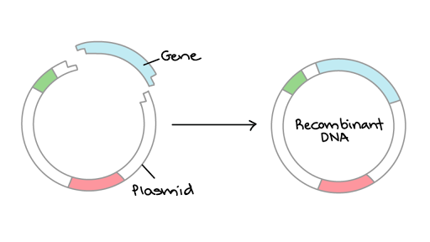
Figure 1: Plasmid recombinant DNA

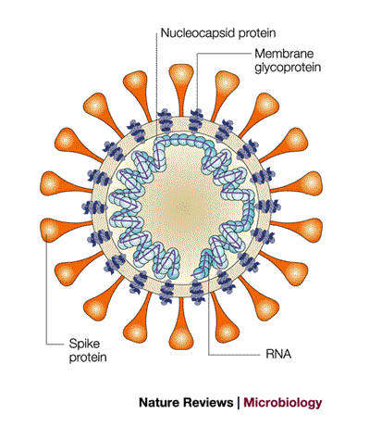
- Shown to the left is model of coronavirus. What protein would you recommend that scientists use in a vaccine? Why is that?
Scientists isolate a COVID-19 gene with the following sequence
TACGTGATCCATGGC
- What is the mRNA sequence for this gene?

- What is the amino acid sequence for this gene?

Part 5- Growing the Vaccine
Once scientists isolate the gene to be used to stimulate a person’s immune system, they can use a process called DNA cloning to grow large quantities of the protein to be used in the vaccine. Below is a sketch of how DNA cloning works with bacteria.
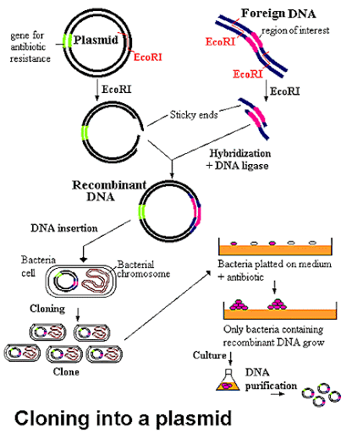
#3
#2
#1
- What seems to be happening in part #1 of the image?

- Part #2 of the image is called bacterial transformation. What seems to be happening in bacterial transformation?

- What is happening in part #3 of the image?

- Why is having the antibiotic resistance in the plasmid important for bacterial transformation?

- Propose how the process shown above can be used to make a recombinant vaccine of COVID-19?

