Design-A-Kid: Hollywood Edition

Background Information
Heritable traits, or genes, are passed from generation to generation with predictable outcomes. Today, you are serving in Hollywood Hospital, and you will use the concepts of Mendelian genetics to help your celebrity clients determine what their baby will look like, and if he or she will be a future star. You will work with another genetic counselor to counsel one celebrity couple.
Use the information these celebrities give you to predict what their baby will look like. Now that you have been trained on Mendel’s rules of dominance, segregation and independent assortment, as well as being skilled in Punnett Squares, Hollywood Hospital has certified you to be a genetic counselor.
Most of the traits in this activity were created to illustrate how human heredity works in a simplified model and to reinforce basic genetic principles. PLEASE DO NOT TELL THE CELEBRITIES! In reality, inherited characteristics of the face are much more complicated than this activity illustrates. Most of the facial characteristics are determined by many genes working together in ways we do not yet understand.

Directions: Read through the packet for this activity. As you work through the activity, fill out the genotype and phenotype of your kid. Spin the penny to determine the traits of your kid. Heads= Dominant and
Tails= Recessive.

Parent Names: ________________________________ and _______________________________
1. Sex of your child:
Genotype: _____________________ Phenotype (male or female): ___________________

Characteristic | Parent 1 Genotype/Phenotype | Parent 2 Genotype/Phenotype | Child Genotype/Phenotype
2. Face Shape
3. Chin Shape
4. Cleft Chin
5. Widow’s Peak
6. Eyebrows I
7. Eyebrows II
8. Eye shape
9. Eye slantedness
10. Eyelashes
11. Lips
12. Freckles on cheeks

Design-A-Kid: Hollywood Edition

Materials:
- Colored pencils (optional)
- Plain paper
- Two pennies

Procedure:
Determine the names of the parents of this child. Remember celebrities love creative names that will help their baby stars stand out! Write name on portrait and data chart.
- Use the photos of your celebrity couple to determine the parent’s genotypes. For dominant phenotypes flip a coin to determine if it will be heterozygous (Heads) or homozygous (Tails)
- For each trait draw a Punnett square and fill it out to see probabilities of your trait. Do this on a separate sheet of paper.
  - Whoever is the father will be on top of the Punnett square
  - Whoever is the mother will be on the side of the Punnett square
- To determine the genotype for each trait listed, each partner will flip a penny. Use the square below as a guide.
Mother/Father | Dad’s allele | Dad’s allele
Mom’s allele | (heads/ heads) | (heads/tails)
Dad’s allele | (tails/heads) | (tails/tails)

- When you have determined all the features for your child, draw what your baby would look like as a teenager. (Do this on a separate piece of paper. You may or may not use color)

For this lab you will need to turn in:
- Genotype/phenotype chart (6 points)
- Completed Punnett squares for all 12 traits (12 points)
- Picture of your child (7 points)
- 25 points total.

Characteristics Chart

1. Sex of your child: Only the father spins the penny because the father determines the baby’s sex. If the father spins a heads (or a Y chromosome) the baby will be a male. If the father spins a tails (or X chromosome) the baby will be a girl. The mother can only give a tails (or an X chromosome). Remember, a female’s sex chromosomes are XX and a male’s sex chromosomes are XY.

2. Face Shape:
Round (RR, Rr) Square (rr)
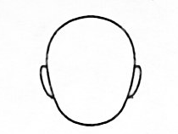
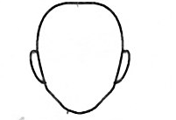

3. Chin Shape
Round (RR, Rr) Square (rr)

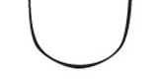
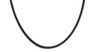

4. Cleft Chin:
Present (AA, Aa) Absent (aa)
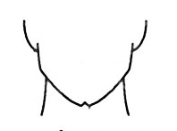
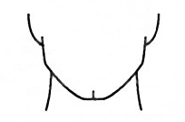

5. Widow’s Peak: The hair-line comes to a point in the center of the forehead.
Present (WW, Ww) Absent (ww)
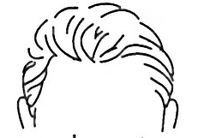
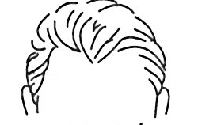

6. Eyebrows I:
Bushy (BB, Bb) Fine (bb)
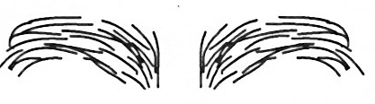

7. Eyebrows II:
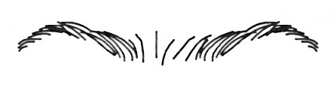
Not connected (NN, Nn) Connected (nn)

8. Eye Shape:
Almond (wide) (AA, Aa) Round (narrow) (aa)
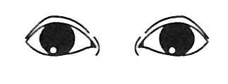
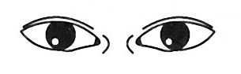

9. Eye Slantedness:
Horizontal (HH, Hh) Upward Slant (hh)
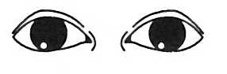
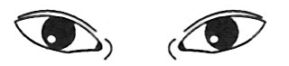

10. Eyelashes
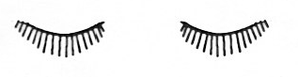
Long (LL, Ll) Short (ll)

11. Lips:
Thick (LL, Ll) Thin (ll)
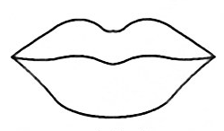
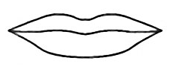

12. Freckles on cheeks:
Present (FF, Ff) Absent (ff)
