Station 1
Digestive Enzymes
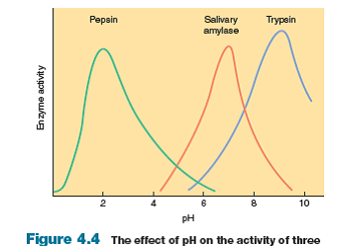
The digestive system uses enzymes to chemically break down polymers of carbohydrates, proteins and lipids into monomers (monosaccharides, amino acids, and fatty acids). Three of these enzymes catalyze (speed up the rate of a reaction) best under different levels of acidity (pH).
- Under what pH conditions would all three enzymes catalyze reactions the slowest?
- What is the best pH level for each enzyme? Why?
- As amylase travels from the mouth (pH 7) to the stomach (pH 2) what would happen to the activity of the enzyme?

Station 2
Intestinal Enzymes
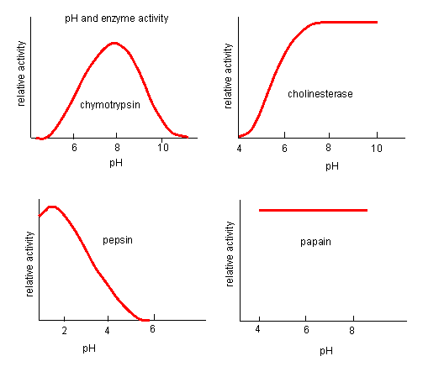
The digestive system uses protease enzymes to chemically break down polymers of proteins into amino acid monomers. The enzyme activity of four proteases at different pH levels is shown above.
- Which protease is most likely to not denature with a change in pH? Why?
- According to the graph, which enzyme is most likely to be denatured at pH 6? Why?
- The small intestine has a pH of 8. Which enzymes are most likely to be active in the small intestine? Which enzyme is least likely to be active?

Station 3
Honey Enzymes

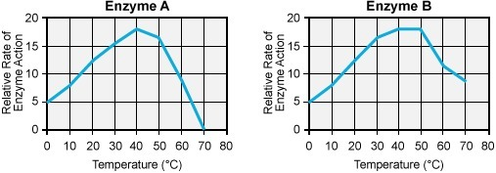

Honey contains enzymes that break down polysaccharides into monosaccharide macromolecules. These enzymes are called amylase and diastase. Amylase (enzyme A) converts starch into the monosaccharide sugar maltose. Diastase (enzyme B) converts starch into the monosaccharide glucose.
- If you were a beekeeper trying to produce the sweetest honey, at what temperature would you keep honey? Why?

- At what temperature would honey likely have a higher concentration of glucose than maltose? Why?

- What temperature would be best to store honey without the enzymes in honey completely breaking down? Why?

Enzymes in Sewage
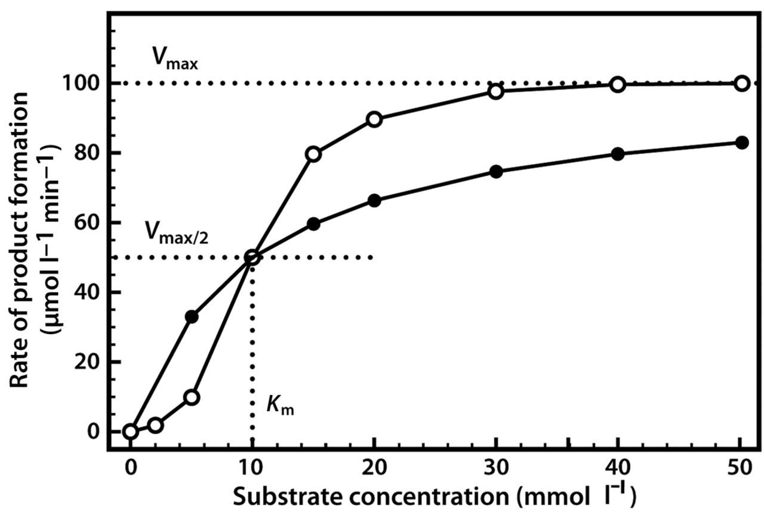
The Fresno wastewater treatment plant uses enzymes to break down waste in sewage. Lipase enzymes break down triglycerides into fatty acids, or polymers into monomers. The graph with white dots represents lipase 1, and the graph with black dots represents lipase 2.
- If the treatment plant only reads a small amount of lipids in sewage, which enzyme would break down lipids the quickest? Why?
- If the treatment plant reads a high concentration of lipid, which enzyme would be best to add to the treatment? Why?
- The treatment plant can only afford to buy one enzyme. The average amount of lipids in Fresno sewage is 15mmol. Which enzyme would you suggest they purchase and why? Both enzymes cost the same amount.

