Introduction to Enzymes – Khan Academy

Introduction
As a kid, I wore glasses and desperately wanted a pair of contact lenses. When I was finally allowed to get contacts, part of the deal was that I had to take very, very good care of them, which meant washing them with cleaner every day, storing them in a sterile solution, and, once a week, adding a few drops of something called “enzymatic cleaner.” I didn’t know exactly what “enzymatic cleaner” meant, but I did learn that if you forgot you’d added it and accidentally put your contacts in your eyes without washing them, you were going to have burning eyes for a good fifteen minutes.
As I would later learn, all that “enzymatic” meant was that the cleaner contained one or more enzymes, proteins that catalyzed particular chemical reactions – in this case, reactions that broke down the film of eye goo that accumulated on my contacts after a week of use. (Presumably, the reason it stung when I got it in my eyes was that the enzymes would also happily break down eye goo in an intact eye.) In this article, we’ll look in greater depth at what an enzyme is and how it catalyzes a particular chemical reaction.
Enzymes and activation energy
A substance that speeds up a chemical reaction—without being a reactant—is called a catalyst. The catalysts for biochemical reactions that happen in living organisms are called enzymes. Enzymes are usually proteins. Enzymes perform the critical task of lowering a reaction's activation energy—that is, the amount of energy that must be put in for the reaction to begin. Enzymes work by binding to reactant molecules and holding them in such a way that the chemical bond-breaking and bond-forming processes take place more readily.
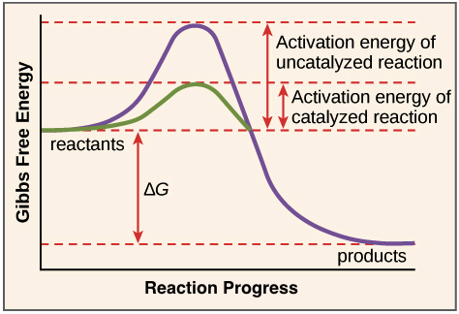
_Image modified from "Potential, kinetic, free, and activation energy: Figure 5," by OpenStax College, Biology, CC BY 3.0._
Active sites and substrate specificity
To catalyze a reaction, an enzyme will grab on (bind) to one or more reactant molecules. These molecules are the enzyme's substrates. In some reactions, one substrate is broken down into multiple products. In others, two substrates come together to create one larger molecule or to swap pieces. In fact, whatever type of biological reaction you can think of, there is probably an enzyme to speed it up! The part of the enzyme where the substrate binds is called the active site(since that’s where the catalytic “action” happens).
A substrate enters the active site of the enzyme. This forms the enzyme-substrate complex. The reaction then occurs, converting the substrate into products and forming an enzyme products complex. The products then leave the active site of the enzyme.
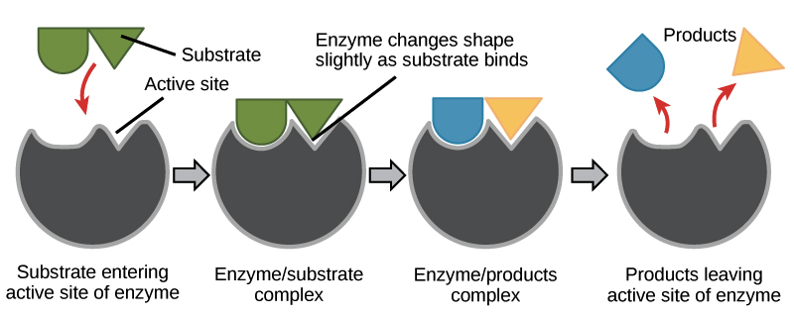
Proteins are made of units called amino acids, and in enzymes that are proteins, the active site gets its properties from the amino acids it's built out of. The set of amino acids found in the active site, along with their positions in 3D space, give the active site a very specific size, shape, and chemical behavior. Thanks to these amino acids, an enzyme's active site is uniquely suited to bind to a particular target—the enzyme's substrate or substrates—and help them undergo a chemical reaction.
Environmental effects on enzyme function
Because active sites are finely tuned to help a chemical reaction happen, they can be very sensitive to changes in the enzyme’s environment. Factors that may affect the active site and enzyme function include:
- Temperature. A higher temperature generally makes for higher rates of reaction, enzyme-catalyzed or otherwise. However, either increasing or decreasing the temperature outside of a tolerable range can affect chemical bonds in the active site, making them less well-suited to bind substrates. Very high temperatures may cause an enzyme to denature, losing its shape and activity.
- pH. pH can also affect enzyme function. Active site amino acids often have acidic or basic properties that are important for catalysis. Changes in pH can affect these amino acids and make it hard for substrates to bind. Enzymes work best within a certain pH range, and, as with temperature, extreme pH values (acidic or basic) can make enzymes denature.
Induced fit
The matching between an enzyme's active site and the substrate isn’t just like two puzzle pieces fitting together (though scientists once thought it was, in an old model called the “lock-and-key” model). Instead, an enzyme changes shape slightly when it binds its substrate, resulting in an even tighter fit. This adjustment of the enzyme to snugly fit the substrate is called induced fit.

When an enzyme binds to its substrate, we know it lowers the activation energy of the reaction, allowing it to happen more quickly. But, you may wonder, what does the enzyme actually do to the substrate to make the activation energy lower?
The answer depends on the enzyme. Some enzymes speed up chemical reactions by bringing two substrates together in the right orientation. Others create an environment inside the active site that's favorable to the reaction (for instance, one that's slightly acidic or non-polar). The enzyme-substrate complex can also lower activation energy by bending substrate molecules in a way that facilitates bond-breaking, helping to reach the transition state. Finally, some enzymes lower activation energies by taking part in the chemical reaction themselves. That is, active site residues may form temporary covalent bonds with substrate molecules as part of the reaction process.
An important word here is "temporary." In all cases, the enzyme will return to its original state at the end of the reaction—it won't stay bound to the reacting molecules. In fact, a hallmark property of enzymes is that they aren't altered by the reactions they catalyze. When an enzyme is done catalyzing a reaction, it just releases the product (or products) and is ready for the next cycle of catalysis.

