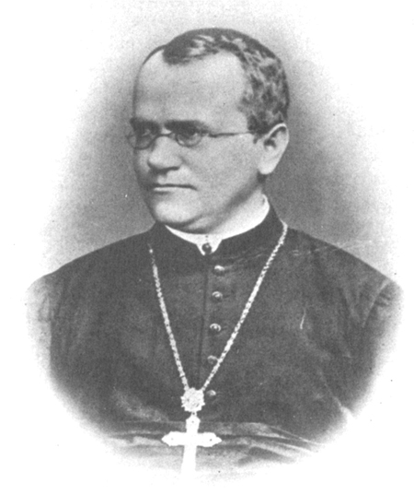
Mendel Article
Johann Gregor Mendel (1822–1884), often called the “father of genetics,” was a teacher, lifelong learner, scientist, and man of faith. It would be fair to say that Mendel had a lot of grit: he persevered through difficult circumstances to make some of the most important discoveries in biology.
As a young man, Mendel had difficulty paying for his education due to his family's limited means, and he also suffered bouts of physical illness and depression; still, he persevered to graduate from high school and, later, university. After finishing university, he joined the Augustinian Abbey of St. Thomas in Brno, in what is now the Czech Republic. At the time, the monastery was the cultural and intellectual hub of the region, and Mendel was immediately exposed to new teachings and ideas.
His decision to join the order (against the wishes of his father, who expected him to carry on the family farm) appears to have been motivated in part by a desire to continue his education and pursue his scientific interests. Supported by the monastery, he taught physics, botany, and natural science courses at the secondary and university levels.
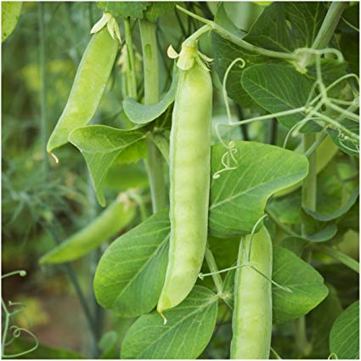
Mendel’s model system: The pea plant
Mendel carried out his key experiments using the garden pea, Pisum sativum, as a model system. Pea plants make a convenient system for studies of inheritance, and they are still studied by some geneticists today.
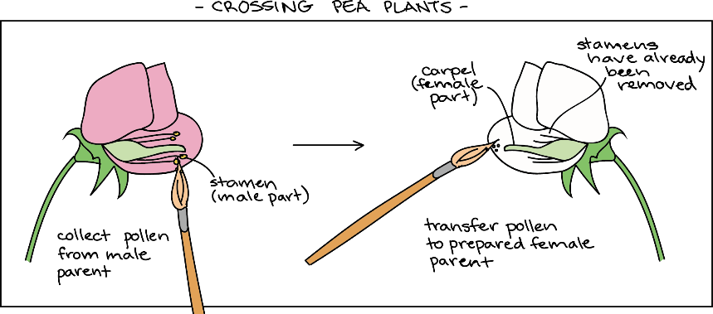
Useful features of peas include their rapid life cycle and the production of lots and lots of seeds. Pea plants also typically self-fertilize, meaning that the same plant makes both the sperm and the egg that come together in fertilization. Mendel took advantage of this property to produce true-breeding pea lines: he self-fertilized and selected peas for many generations until he got lines that consistently made offspring identical to the parent (e.g., always short).
Pea plants are also easy to cross, or mate in a controlled way. This is done by transferring pollen from the anthers (male parts) of a pea plant of one variety to the carpel (female part) of a mature pea plant of a different variety. To prevent the receiving plant from self-fertilizing, Mendel painstakingly removed all the immature anthers from the plant’s flowers before the cross.
Because peas were so easy to work with and prolific in seed production, Mendel could perform many crosses and examine many individual plants, making sure that his results were consistent (not just a fluke) and accurate (based on many data points).
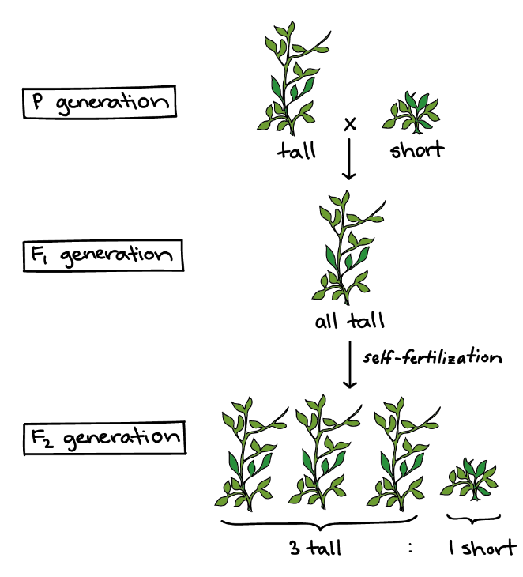
Mendel’s experimental setup
Once Mendel had established true-breeding pea lines with different traits for one or more features of interest (such as tall vs. short height), he began to investigate how the traits were inherited by carrying out a series of crosses.
First, he crossed one true-breeding parent to another. The plants used in this initial cross are called the P generation, or parental generation.
Mendel collected the seeds from the P generation cross and grew them up. These offspring were called the F1 generation, short for first filial generation. (Filius means “son” in Latin, so this name is slightly less weird than it seems!)
Once Mendel examined the F1 plants and recorded their traits, he let them self-fertilize naturally, producing lots of seeds. He then collected and grew the seeds from the F1 plants to produce a F2 generation, or second filial generation. Again, he carefully examined the plants and recorded their traits.
Below is data from Mendel’s crosses. Find the ratios for each cross below. The dominant trait is left trait (pink flower) and the recessive trait is the right trait (white flower). The F1 generation for all traits was 100% dominant.
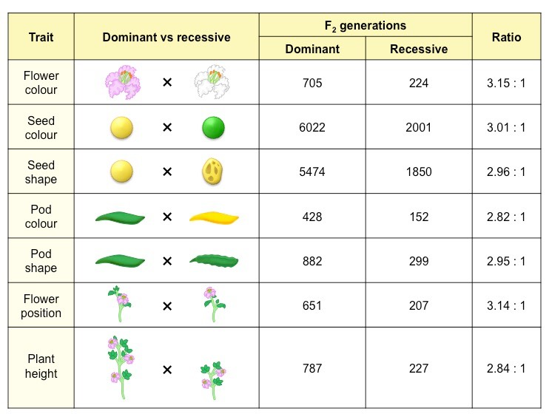

What pattern occurred when the P generation was crossed?

What pattern emerged when the F1 generation was crossed?

What is a relationship between dominant and recessive traits?

Using your knowledge of homologous chromosomes, create an explanation for why the recessive trait reappears in the F2 generation? Use vocabulary from the “Chromosomes and Genetics” article.

