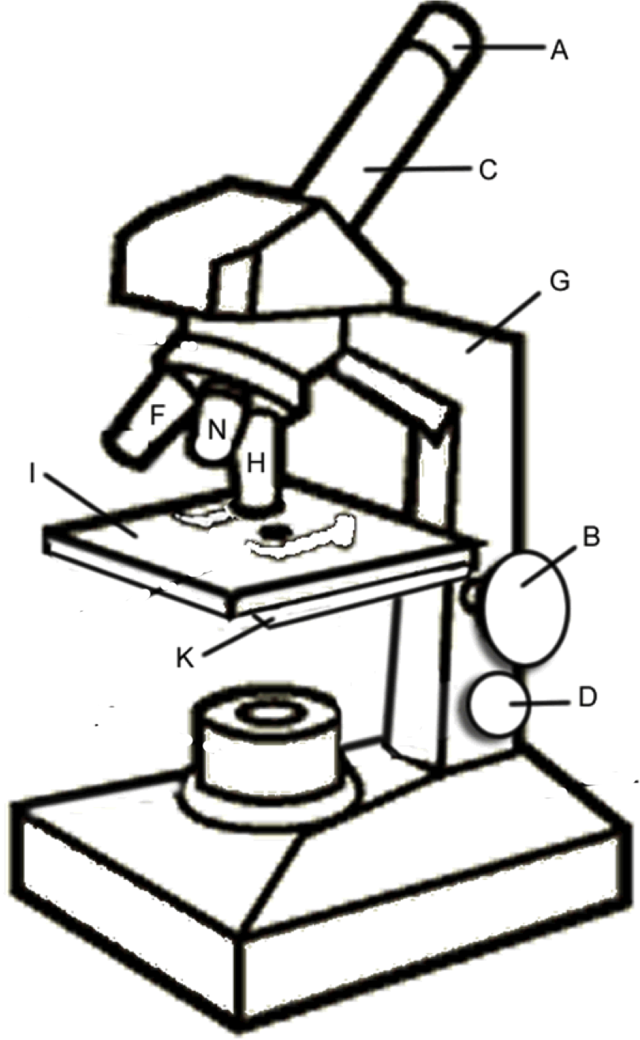

E

Objective Lenses:
N=

F=

H=

J

L
M

Parts of a Microscope:

The most familiar type of microscope is the standard light microscope. The base (L) and arm (G) are usually one single piece of cast metal. The arm is the correct place to grip/hold the microscope when carrying it while supporting the base with the palm of your other hand. The stage (l) is the platform that supports the slide or specimen to be observed. The stage has a hole in its center to allow light to pass through, so specimens must be positioned over the top of this hole. You can control how much light goes through the specimen by adjusting the diaphragm (K). It has a range of 1 to 5, with 5 being the most light. Since any slight movement of a specimen is magnified many times, the slide is usually held down by a pair of stage clips (J).
Light microscopes use either a bulb or a mirror (M) as their light source. Never use direct sunlight; it may damage your eyes. The switch for this light is usually found on the base of the microscope.
After the light has passed through the slide/specimen, it enters the objective lens (often called “objective” for short). The shortest of the three objectives is the scanning-power objective lens (N), and has a power of 4X. The second objective is the low-power objective (F), which is almost always made to produce a magnification of 10 times (10X). The high-power objective lens (H) has a magnification of 40X.
The body tube (C) allows the light from the objective lenses to pass upward to form the first magnified image; that image is further magnified by the eyepiece or ocular lens (A). The eyepiece is usually 10X. The total magnification obtained is the produce of the eyepiece times that of the objective lens. You can easily switch objectives by turning the rotating nosepiece (E).
The coarse adjustment knob (B) is the larger on your microscope. You will use this primarily to focus on your specimen. DO NOT USE THE COARSE ADJUSTMENT KNOB ON HIGH POWER (40X), it will crack your slide. The fine adjustment knob (D) is also for minute (small) focusing. You use this after you have focused with the coarse adjustment knob and want a sharper (clearer) image.

How to Focus a Microscope

1. Have the microscope on the lowest power objective lens (4X).
2. Place the slide under the stage clips on the stage.
3. Turn on the light source.
4. First, bring the image into focus using the coarse adjustment knob.
5. Second, bring the image into better focus using the fine adjustment knob.
6. Once the image is in focus, rotate the revolving nosepiece and move to the middle objective lens (10X). * You should hear a click to know the objective lens is correctly in place.
7. Bring the image back into focus only using the fine adjustment knob.
8. Repeat steps 6-7 to view the image through the highest power objective lens (40X).

- 10x magnification. View objects through
- Supports the microscope
- Rotate to switch objective lenses
- Magnifies object
- Supports the slide
- Used for primary focusing
- Supports microscope when carried
- Projects light upwards on slide
- Holds slide in place
- Regulates amount of light on slide
- Used for minutes shaper focusing

