Modelling Photosynthesis
“How does a chloroplast convert light energy into chemical energy stored as glucose?”
Light + 6CO₂ + 6H₂O → C₆H₁₂O₆ + 6O₂
Task:
In this activity your group will be working together to model the process of photosynthesis. Each group member will be a structure involved in photosynthesis. As a group your goal is to make a molecule of glucose from carbon dioxide and water.
Materials:
Role Cards | Toothpicks (chemical bonds)
Marshmallow (carbon) x6 | Marshmallow (hydrogen) x12
Marshmallow (oxygen) x18 | NADP Card x2
ADP | Phosphates x 12
Procedure:
- Build reactants. Water has single bonds. Carbon dioxide has double bonds
- Stomata 1 collects water. Stomata 2 collects carbon dioxide
- Shine a light on thylakoids.
- Start the process of photosynthesis.
- Call over Mr. Gingold when glucose is constructed (picture of glucose on projector)
Structure (Member role) | Role
Stoma | - Deliver water  - Take out oxygen
Thylakoid (light-dependent reaction) | - Transfer light energy to ATP (add a P to ADP card)  - Transfer hydrogen from water to NADP (Add a hydrogen marshmallow to NADP card)  Synthesize oxygen gas
Stroma (light-independent reaction) | - Convert carbon dioxide into glucose (recombine hydrogen, oxygen, and carbon marshmallows into glucose)  - Recycle NADP and ADP (return NADP and ADP cards to thylakoid)
Stoma | Deliver carbon dioxide
Conclusion: Diagram the chloroplast below given your knowledge of photosynthesis.
- Label reactants and products
- Label two reactions
- Label structure of photosynthesis
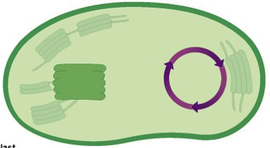
- How is light converted into chemical energy in the thylakoid?

- What happened to water in the thylakoids?

- How is glucose made in the stroma?

- What is the role of ADP and NADP in photosynthesis?

- Was there anything wrong with your model? Did you have to break the rules? Why?

