Monohybrid Crosses Practice

Is Bb a genotype or phenotype? ________________ Is hair color a genotype or phenotype ____________
Is hair color a genotype or phenotype? ______________ Is BB homozygous or heterozygous? ________________
Is bb homozygous or heterozygous? ___________________ Is Bb homozygous or heterozygous? ______________
Match the following terms:
_____ Heterozygous A. Dominant allele
_____ Homozygous B. Recessive allele
_____ B C. Heterozygous genotype
_____ b D. Homozygous dominant genotype
_____ BB E. Homozygous recessive genotype
_____ Bb F. The two alleles are the same
_____ bb G. The two alleles are different
1. A widow’s peak (B) is dominant to not having a widow’s peak (b). A homozygous male with a widow’s peak marries a homozygous recessive female with no widow’s peak. Determine the possible offspring from this cross.

Probability widow’s peak ________ Probability no widow’s peak _____
Probability homozygous dominant _______
Probability homozygous recessive _______
Probability heterozygous ________

2. In purple people eater, having one-horn is dominant (B) and having no-horns is recessive (b). Cross a heterozygous one-horned male purple eater with a female purple people eater that has no horns to determine the possible offspring.

Probability one horn _____ Probability no horns ______
Probability homozygous dominant _______
Probability homozygous recessive _______
Probability heterozygous ________

3. The gene that results in a person being albino is a recessive trait (aa). Normal pigmented skin (A) is dominant to albino skin (a). Two heterozygous normally pigmented parents (Aa) have an albino baby. They plan to have more children and want to know the chances of having albino and normally pigmented children.
Male genotype: Aa Female genotype: Aa

Probability normal pigment _______ Probability albino ______
Probability homozygous dominant ______
Probability homozygous recessive ______
Probability heterozygous _______

These parents were have normal pigmented skin. How is it possible for them to have a recessive albino child? _________________________________________________________________________________________
4. The couple’s original albino child grows up and marries a heterozygous normally pigmented person, who has an albino sibling. Determine the possible offspring from this cross.

Probability normal pigment _______ Probability albino _______
Probability homozygous dominant _______
Probability homozygous recessive _______
Probability heterozygous ________
5. In chimpanzees, straight fingers are dominant (B) to bent fingers (b). Determine the offspring from a cross between a heterozygous straight fingered chimpanzee and a homozygous bent chimpanzee.
Probability straight fingers ___________ Probability bent fingers _______
Probability homozygous dominant ________
Probability homozygous recessive ________
Probability heterozygous ________

6. The ability to taste a certain chemical, PTC, is an inherited human characteristic. The allele for taster is dominant (D) to that for non-taster (d). Determine the possible offspring from a cross between a heterozygous taster male and a heterozygous taster female.
Probability taster ____________ Probability non-taster _________
Probability homozygous dominant _________
Probability homozygous recessive _________
Probability heterozygous _________

7. In fruit flies, red eye (R) is dominant to pink eye (r). Determine the possible offspring in a cross between a pink eyed male and a heterozygous red eyed female.
Probability red eye ____________ Probability pink eye ________
Probability homozygous dominant ________
Probability homozygous recessive ________
Probability heterozygous ________

8. In humans having freckles (A) is dominant to not having freckles (a). Using the Punnett square below, explain what the genotypes and phenotypes of the parents of this cross would be.
 | ? | ? ?
? | BB | Bb
? ? | Bb | bb

9. The pedigree below shows the pedigree of a family with freckles. Based on the genotypes of the parents above what would be the genotypes of the grandparents? Create Punnett Squares to support your answer.
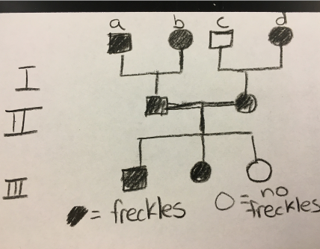
Grandparent a:

Grandparent b:

Grandparent c:

Grandparent d:

10. Think about to Maria and Lucy Aylmer. Now that you know how to use a Punnett Square to conduct a monohybrid cross, create a Punnett Square to show how Maria and Lucy inherited alleles from their parents. While eye color is not a simple Mendelian trait, assume it is for this problem. Blue eyes are recessive to brown eyes. Explain your Punnett square and how the twins inherited the colors they did.

Dad’s phenotype: blue Maria: brown eyes
Mom’s phenotype: brown Lucy: blue eyes

