Non-Disjunction (8) CLASS COPY DO NOT WRITE ON
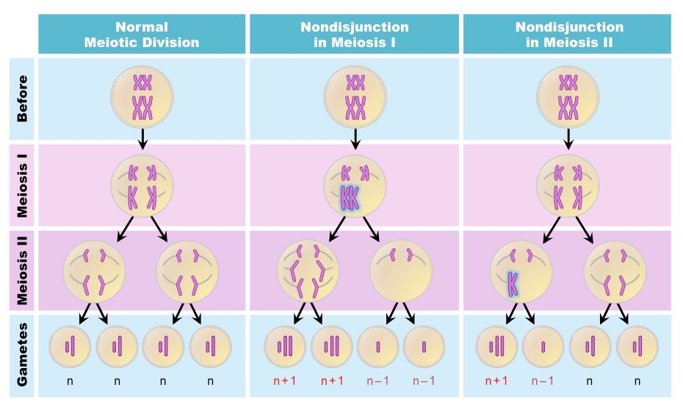
Picture A Picture B Picture C

- Describe what normally happen in meiosis? (phases, how many cells are formed, number of chromosomes in a cell)

- What are some of the major differences you see in Pictures B and C when comparing them to the Picture A?

- What are some similarities you notice between all pictures?

- In what phase of meiosis could an error happen to cause non-disjunction? What kind of error would happen?

- With your partner write a definition for non-disjunction?

