Pedigree Intro (3)
Focus Question: What does my ancestry reveal about me?
Introduction: Genealogy: (from Greek : genea meaning “generation”; and logos meaning “knowledge”) also known as family history, is the study of families and the tracing of their lineages and history.
A pedigree is a visual chart that depicts a family history or the transmission of a specific genetic trait. They can be interesting to view and can be important tools in determining patterns of inheritance of specific traits. Pedigrees are used primarily by genetic counselors when helping couples decide to have children when there is evidence of a genetically inherited disorder in one or both families. They are also used when trying to determine the predisposition of someone to carry a hereditary disease for example, familial breast cancer.

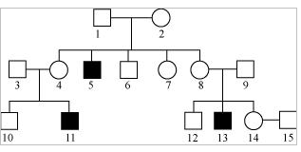
The components of a Pedigree: Squares are used to indicate males in a family.

Circles are used to indicate females.
If the individual is “affected” by the trait (dominant or recessive) we darken the shape.

Sometimes, you will see some shapes filled in only half way- this notation indicates a heterozygous individual or carrier of the trait. Often times this is used when tracking a sex-linked recessive trait on the X chromosome.
A line between a male and female indicates a marriage or mating.
A line drawn down from the marriage/mating line indicates offspring.
Offspring are usually drawn from oldest (left) to youngest (right).
Each generation is represented on the same horizontal level, so the above pedigree shows three generations (the oldest at the top).

Human Pedigrees: Use the pedigree chart to answer questions 1-10. Some of the labels may be used more than once.
_______1. A male
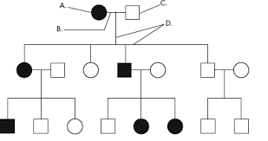
______ 2. A female
I

II

III
______ 3. A marriage/mating
______ 4. A person who expresses the trait.
______ 5. A person who does not express the trait.
______ 6. A connection between parents and offspring.
______ 7. How many affected females are in generation 2?
______ 8. How many unaffected females are in generation 2?
______ 9. How many affected males are in generation 3?
______ 10. How many unaffected males are in generation 3?

Your Task:

- Create your family pedigree tracking one, single gene trait through 3 generations (grandparents → parents → student and siblings)

- Provide a title for your pedigree that identifies the trait you have chosen to follow.

- Make sure to use pedigree symbols accurately; do not forget that symbol shapes matter and symbols should be shaded if they have the trait!

- Use Roman Numerals to identify generations and number the individuals in each generation.

- Be sure to label the symbol that represents you in the pedigree.

- Single gene traits you can choose from:
Trait | Phenotype | Dominant or Recessive | Symbol on Pedigree
Earlobe
Widow’s Peak
Tongue Rolling
Hitchhiker’s Thumb
Dimples
Freckles

Pedigree Trait Selected: _______________

In the table, collect genetic information about your family. If you cannot see a family member in the time frame given, use your best judgement to what trait they may have.
Individual | Relationship to me | Trait | Symbol to be used

