Phases of the cell cycle (1)
“How does a cell grow and multiply?”
Introduction
Have you ever watched a caterpillar turn into a butterfly? If so, you’re probably familiar with the idea of a life cycle. Butterflies go through some fairly spectacular life cycle transitions—turning from something that looks like a lowly worm into a glorious creature that floats on the breeze. Other organisms, from humans to plants to bacteria, also have a life cycle: a series of developmental steps that an individual goes through from the time it is born until the time it reproduces.
The cell cycle can be thought of as the life cycle of a cell. In other words, it is the series of growth and development steps a cell undergoes between its “birth”—formation by the division of a mother cell—and reproduction—division to make two new daughter cells.
Stages of the cell cycle
To divide, a cell must complete several important tasks: it must grow, copy its genetic material (DNA), and physically split into two daughter cells. Cells perform these tasks in an organized, predictable series of steps that make up the cell cycle. The cell cycle is a cycle, rather than a linear pathway, because at the end of each go-round, the two daughter cells can start the exact same process over again from the beginning.
In eukaryotic cells, or cells with a nucleus, the stages of the cell cycle are divided into two major phases: interphase and the mitotic (M) phase.
- During interphase, the cell grows and makes a copy of its DNA.
- During the mitotic (M) phase, the cell separates its DNA into two sets and divides its cytoplasm, forming two new cells.

A cell can divide for many different reasons. First cells can only be so big. If a cell’s volume is too large it has a harder time maintaining homeostasis and responding to the environment. By dividing it can stay at a proper size. Second an organism can divide its cells to grow. As you grow in height, cells in your skin, muscles, and bones are multiplying. Third cells multiply to recover from injury. If you cut your skin, then your skin cells can divide to repair that wound.

Interphase
Let’s enter the cell cycle just as a cell forms, by division of its mother cell. What must this newborn cell do next if it wants to go on and divide itself? Preparation for division happens in three steps:

- G1 phase. During G1 phase, also called the first gap phase, the cell grows physically larger, copies organelles, and makes the molecular building blocks it will need in later steps.
- S phase. In S phase, the cell synthesizes a complete copy of the DNA in its nucleus. It also duplicates a microtubule-organizing structure called the centrosome. The centrosomes help separate DNA during M phase.
- G2 phase. During the second gap phase, or G2 phase, the cell grows more, makes proteins and organelles, and begins to reorganize its contents in preparation for mitosis. G2 phase ends when mitosis begins.
The G1, S, and G2 phases together are known as interphase. The prefix inter- means between, reflecting that interphase takes place between one mitotic (M) phase and the next.
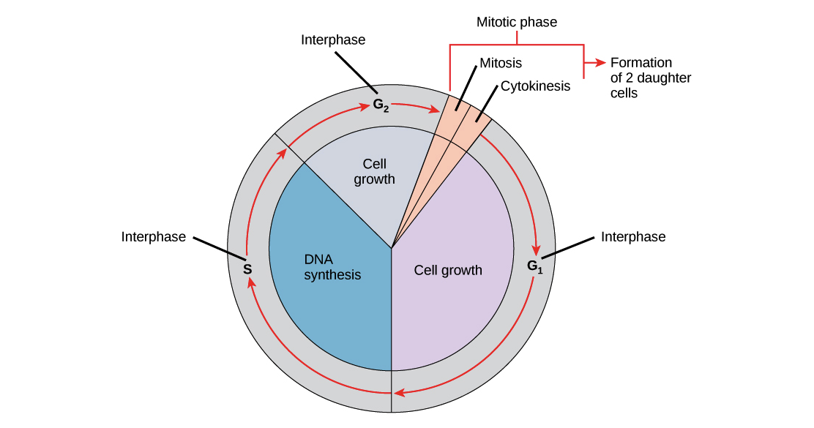
Image of the cell cycle. Interphase is composed of G1 phase (cell growth), followed by S phase (DNA synthesis), followed by G2 phase (cell growth). At the end of interphase comes the mitotic phase, which is made up of mitosis and cytokinesis and leads to the formation of two daughter cells. Mitosis precedes cytokinesis, though the two processes typically overlap somewhat.
Image credit: "The cell cycle: Figure 1" by OpenStax College, Biology (CC BY 3.0).
M phase
During the mitotic (M) phase, the cell divides its copied DNA and cytoplasm to make two new cells. M phase involves two distinct division-related processes: mitosis and cytokinesis. In mitosis, the nuclear DNA of the cell condenses into visible chromosomes and is pulled apart by the mitotic spindle, a specialized structure made out of microtubules. Mitosis takes place in four stages: prophase (sometimes divided into early prophase and prometaphase), metaphase, anaphase, and telophase.
In cytokinesis, the cytoplasm of the cell is split in two, making two new cells. Cytokinesis usually begins just as mitosis is ending, with a little overlap. Importantly, cytokinesis takes place differently in animal and plant cells.
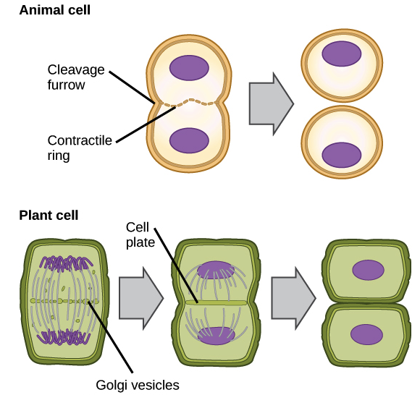
Cytokinesis in animal and plant cells.
Image credit: "The cell cycle: FIgure 4" by OpenStax College, Biology (CC BY 3.0).
- In animals, cell division occurs when a band of cytoskeletal fibers called the contractile ring contracts inward and pinches the cell in two, a process called contractile cytokinesis. The indentation produced as the ring contracts inward is called the cleavage furrow. Animal cells can be pinched in two because they’re relatively soft and squishy.
- Plant cells are much stiffer than animal cells; they’re surrounded by a rigid cell wall and have high internal pressure. Because of this, plant cells divide in two by building a new structure down the middle of the cell. This structure, known as the cell plate, is made up of plasma membrane and cell wall components delivered in vesicles, and it partitions the cell in two.
Cell cycle exit and G0
What happens to the two daughter cells produced in one round of the cell cycle? This depends on what type of cells they are. Some types of cells divide rapidly, and in these cases, the daughter cells may immediately undergo another round of cell division. For instance, many cell types in an early embryo divide rapidly, and so do cells in a tumor.
Other types of cells divide slowly or not at all. These cells may exit the G1phase and enter a resting state called G0 phase. In G0, a cell is not actively preparing to divide, it’s just doing its job. For instance, it might conduct signals as a neuron (like the one in the drawing below) or store carbohydrates as a liver cell. G0 is a permanent state for some cells, while others may re-start division if they get the right signals.

Review Questions:
What is the end goal of the cell cycle?

What are three reasons cells divide?

Describe what happens in each step.
- Interphase
- M Phase (mitosis)
- G1
- S
- G2
- Cytokinesis
- G0
How is cytokinesis different in animal cells and plant cells?
What are chromosomes?
How are chromosomes separated in mitosis?

