Scientific Method Notes
Scientific Method:

Observation | Inference
Qualitative

Quantitative

Observation v. Inference Practice (make 3 qualitative observations)
Picture #:
Observations:________________________________________________________________________________________________________________________________________________________
Inference:_________________________________________________________________________
Picture #:
Observations:________________________________________________________________________________________________________________________________________________________
Inference:_________________________________________________________________________
Picture #:
Observations:________________________________________________________________________________________________________________________________________________________
Inference:_________________________________________________________________________
Picture #:
Observations:________________________________________________________________________________________________________________________________________________________
Inference:_________________________________________________________________________
Picture #:
Observations:________________________________________________________________________________________________________________________________________________________
Inference:_________________________________________________________________________
Scientific Questions:

Hypothesis:

Picture #:
Question 1:________________________________________________________________________
Question 2: ________________________________________________________________________
Hypothesis:__________________________________________________________________________________________________________________________________________________________
Controlled Experiment:

Independent Variable:
Dependent Variable:
Controlled Variable:
Control Group:
Experimental Group:
Ex 1:
Independent Variable:
Dependent Variable:
Control:
Ex 2:
Independent Variable:
Dependent Variable:
Control:
Ex 3:
Independent Variable:
Dependent Variable:
Control:

Data:
Quantitative:
Qualitative:
Metric System:
Measurement | Units

Measuring length: Select two objects to measure the height, width, and length in centimeters (cm) and millimeters (mm)
 | Object: | Object:
Length | Cm: mm: | Cm: mm:
Width | Cm: mm: | Cm: mm:
Height | Cm: mm: | Cm: mm:

Station 3: Measuring Volume: Use a graduated cylinder and balance to find the information below. Remember to subtract the mass of the cylinder in your measurements.
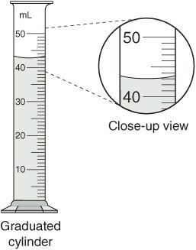
11. Empty graduated cylinder: g
12. 43 ml of water: g
13. 97 ml of water: g
14. *Marble: ___________ ml
Measure at bottom of meniscus
Station 4: Measuring Mass: Select three
objects to measure with a balance.
15. Object 1: g
16. Object 2: g
17. Object 3: g

