Name:
Date:
Unit 1 Quiz 2 Study Guide
Do on a separate sheet of paper. Due Monday
- What is the difference between a monomer and a polymer?
- For each macromolecule, what is a monomer and a polymer for each? Draw an example?
- What is a function for each macromolecule?
- What are some properties of phospholipids?
- What parts does a nucleotide have? Draw an example.
- How does an enzyme affect a chemical reaction? List two examples.
- What happens to enzymes in extreme environmental conditions?
- 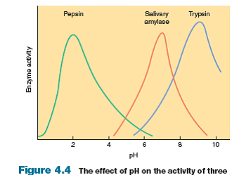
For the above graph describe the behavior of each enzyme.
At what pH do they catalyze a reaction the fastest?

At what pH do they denature?
- In the graph above, what enzyme would do best in an acidic environment like the stomach? Why?

- Draw a cell membrane. Include how the phospholipid is structured and include other substances in the cell membrane.
- How does a cell membrane help with homeostasis?
- What molecules can easily pass through a cell membrane? What molecules have a difficult time passing through a cell membrane?
- How do small, non polar molecules pass through the cell membrane?
- How do large, polar molecules pass through the cell membrane?
- How can a particle pass through a cell membrane with no energy?
- In what situations does a cell need to use energy to move something across a membrane? Why?
- What is osmosis?
- How do hypertonic environments affect a cell? Draw an example.
- How do hypotonic environments affect a cell? Draw an example.
- How do isotonic environments affect a cell? Draw an example.

