Biology Name____________________ NB#______
Lab 1: A Biological Experiment

I. Background Information: yeast is a microscopic fungus. Yeast is a type of organism known as a saprophyte. Saprophytes require a source of ready-made food such as sugar or starch. Given adequate food, warmth and moisture, yeast grows rapidly and multiply. One product of yeast activity is carbon dioxide gas.
A student might want to culture some yeast in the laboratory. He is interested in the relationship between the activity of yeast and the amount of food supplied. How can we design an experiment to determine the relationship between the activity of yeast and the amount of molasses (food) given the yeast?

A. State the problem: (Research Question) _________________________________________________________________________________________________________________________________________________________________________________________________________________________________________________________________.

B. State a hypothesis: _________________________________________________________________________________________________________________________________________________________________________________________________________________________________________________________________.

C. Identify the variable (what is going to be changed?) in the experiment: _____________________________________________________________________________________.

II. Materials: Each lab team will need:
- Test tube rack 6. 25 mL graduated cylinder
- 5 large and 5 small test tubes 7. Parafilm or foil
- Molasses stock solution 8. Graph paper (day 2)
- Yeast suspension 9. Millimeter ruler (day 2)
- 50 ml graduated cylinder

III. Procedures: Day 1
- Label 5 clean test tubes 1-5. Place in rack.
- Measure 15 ml of stock molasses solution. Pour this molasses into test tube #1.
- Pour 25 ml of stock molasses into your large graduated cylinder. Add 25 ml H2O
- Pour 15 ml of mixed molasses into test tube #2.
- Dump out 10 ml (down drain) leaving 25 ml in large graduated cylinder.
- Add 25 ml of H2O – you now have 50 ml again. Mix (invert the liquid back and forth gently to mix).
- Measure 15 ml into test tube #3.
- Dump 10 ml (down drain).
- Add 25 ml H2O, mix again. (You’ll have 50 ml).
- Measure 15 ml – add to tube #4.
- Dump 10 ml, leaving 25 ml. Add 25 ml H2O. Mix.
- Measure 15 ml into test tube #5.
- Add 10 drops of yeast to each of your 5 tubes. Be sure to stir up the yeast before filling dropper each time.
- Add a small test tube inverted (up-side down) to each of your tubes. First with molasses as demonstrated by the instructor. All air must be gone from the inverted test tube. Cover each test tube with a small piece of parafilm or aluminum foil.
15. Label your rack and place on nearest shelf.
16. Clean up: wash your graduated cylinders. Return yeast and molasses to supply cart, wash and dry your lab.

IV Procedures: Day 2
1. Measure the length of the carbon dioxide (gas) bubble in each small test tube. Record on data chart.
2. Dispose of aluminum foil. Wash your test tubes in warm water. Return to supply cart. Wash and dry lab area.
V. Data:
Tube Number mm of CO2 Collected
1
2
3
4
5

VI Results:
1. The stock solution you poured into tube # 1 was 25% molasses and 75% water. Give the % molasses in each tube.
Tube Number % molasses
1 | 25
2
3
4
5

Graphing: Title:

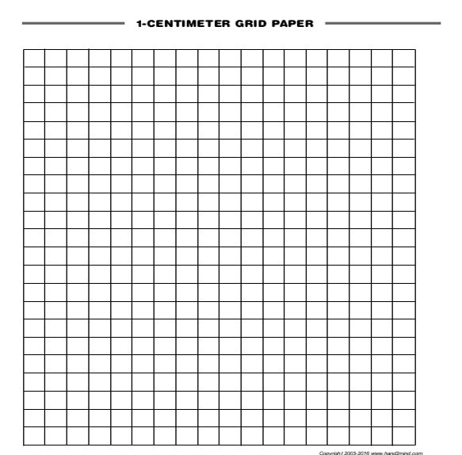

2. Why did you have to mix the yeast mixture before measuring out the drops into the test tubes?
_____________________________________________________________________________
_____________________________________________________________________________
3. Using your data chart, what measurements were taken to determine yeast activity?
_____________________________________________________________________________
_____________________________________________________________________________
4. Consider your hypothesis. Would you conclude that your data supports your hypothesis, rejects your
hypothesis, or is unclear. Explain your answer:___________________________________________
_____________________________________________________________________________
_____________________________________________________________________________
5. Based upon one experiment, you probably would not be certain of your findings. What might you do to
be more confident in your findings?__________________________________________________
6. If you were to publish this investigation so biologists could learn your about finding what information would
You include?___________________________________________________________________
7. You have been asked to complete a follow up experiment to test yeast activity, and you are not allowed to vary the amount of molasses (food) or water given to the yeast. Explain a different variable you can use to test yeast activity and how you would test it. ___________________________________________________________________________________________________________________________________________________________________________________________________________________________________________________________________________________________________________________________________________________________________________________________________________
8. What were some sources of experimental error that could have occurred in this lab? _____________________________________________________________________________________________________________________________________________________________________________________________________________________________________________

